

**PRESS RELEASE** Prague, 13th December 2016

**BB Centrum and Waltrovka were the main themes of the Construction Forum discussion**

**The main idea of the meeting on the theme “City in a city: BB Centrum and Waltrovka from the view of the architect and developer” was to present a detailed look at two significant Prague projects, not only from the perspective of the offer of new office and residential spaces in Prague, but mainly from an urbanistic perspective, looking at the resulting civil amenities and traffic accessibility of the projects. Radim Passer (the Chairman of the Board of Directors of PASSERINVEST GROUP) and Jan Aulík, BB Centrum’s central architect (Aulík Fišer architekti) participated on behalf of the multifunctional BB Centrum complex in Prague 4, with Petr Palička (the Managing Director of Penta Investments) and Jakub Cigler (Jakub Cigler Architekti) speaking on behalf of the Waltrovka project. The interesting discussion took place in November in the spaces of the Bethany Social Centre in Prague’s BB Centrum.**

In his contribution Radim Passer, the founder and Chairman of the Board of Directors of PASSERINVEST GROUP, the developer of the BB Centrum project, focussed primarily on the important connection of commercial and residential spaces with an offer of shops and services within walking distance, with opportunities for education and cultural activities, sports and relaxation. He presented this all using the current arrangement of BB Centrum, which includes two parks, a preschool, school, playground and sports facilities, restaurants, cafés, a post office, pharmacy and many other services.

Petr Palička, the Managing Director of Penta Investments, presented the Waltrovka project and the planned harmonisation of office and residential spaces with services meant for their tenants, owners, inhabitants from the area and the public at large. Together they agreed on the need for a discussion between the developer and the relevant state authorities from the first steps of the projects’ preparations. This communication should then lead to the construction of a joint project in all its aspects, and thus they will not be merely a developer constructing a building without any related services for the needs of the users and inhabitants from the vicinity.

Sixty listeners from the area of real estate and development participated in the meeting, with representatives from the media and the professional public also attending.

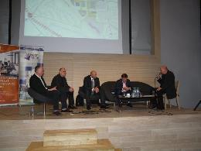

From the left: Jakub Cigler, Jakub Cigler Architekti, Jan Aulík, Aulík Fišer architekti, Radim Passer, PASSERINVEST GROUP, Petr Palička, Penta Investments, a Petr Bým, Stavební fórum

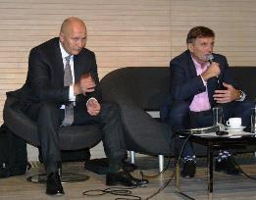

From the left: Radim Passer, PASSERINVEST GROUP

a Petr Palička, Penta Investments

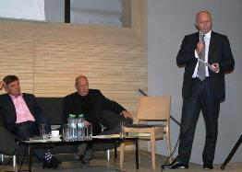

From the left: Petr Palička, Penta Investments, Petr Bým, Stavební fórum a Radim Passer, PASSERINVEST GROUP

For more information and photographs in print quality please contact:

Kristýna Samková**,** Marketing manager

**PASSERINVEST GROUP, a.s.**

Tel.: (+420) 221 582 111, fax: (+420) 222 515 521

Mobil: (+420) 602 186 708

E-mail: [Kristyna.Samkova@Passerinvest.cz](mailto:Kristyna.Samkova@Passerinvest.cz)

[www.passerinvest.cz](http://www.passerinvest.cz/), [www.bbcentrum.cz](http://www.bbcentrum.cz)

Marcela Štefcová

**Crest Communications a.s.**

Tel.: (+420) 222 927 125

Mobil: (+420) 731 613 669

E-mail: marcela.stefcova@crestcom.cz

**About the Developer**

**PASSERINVEST GROUP, a.s.,** founded in 1991 by Radim Passer, is a purely Czech development and investment company whose name is associated in particular with the **BB Centrum** multifunctional complex in Prague 4 - Michle. With this project, the most successful and extensive Czech project of its type, the company has built its excellent reputation both at home and at the international level. Contributing to this is not only the high quality of the projects completed to date, but also its high level of service, its sense of fair play, its positive relationship with the tenants and users of its buildings, and its sense of responsibility towards society and the environment. **PASSERINVEST GROUP**’sportfolioincludes other interesting development projects.